 Dear Parents

AJ Jacobs P/S

Stationery list 2024

Grade 5

**It is compulsory for your child to have these items at school every day.**

**Please note that all of this must be marked clearly.**

**Mark each item separately; not only the packet.**

These items can be given to the register teacher on the first day. It will be kept safe until the learner needs something. This will prevent stationery from getting lost or stolen!!

|  |  |
| --- | --- |
| 1x | Ordinary schoolbag with dividers big enough for A4 books |
| 2x | Rulers **(30cm and mm)** |
| 4x | 2H/HB pencils **per term (16 for the year)** |
| 2x | Big tube Pritt **per term (8 for the year)** |
| 2x | Packet of colour pencils (12 pack) |
| 1x | Blunt nose scissor |
| 4x | Pencil sharpener with holder |
| 4x | Rubbers/Erasers |
| 5x | Blue pens **per term (20 for the year)** |
| 2x | Green pens **per term** – **Compulsory (NO NEON or KOKI PENS)** |
| 2x | Highlighters – any colours |
| 1x | Pocket dictionary (OXFORD) – **Afrikaans and English EXPLAINER (must)** |
| 1x | Pencil bag or Space case |
| 1x | Packet of colour pens **(NO NEON PENS)** |
| 1x | Circuit (To build in class – it is a must) |
| 1x | Modelling clay – 500g |
| 1x | 24 colours wax crayons |
| 1x | Small wood glue |
| 30x | Plastic book covers |
| 2x | Paint brushes number 8 and 10 |

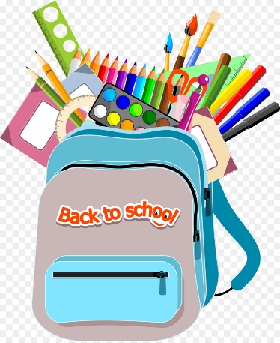**All these items must please be at school on the very first day!!**

|  |  |
| --- | --- |
| 1x | Pack of copy papers (500 pages) |
| 20x | Pink cardboards (No need to mark) |
| 20x | Bantex plastic pockets (No need to mark) |
| 4x | Quotation folders |
| 4x | Toilet rolls |
| 1x | Box of tissues |
| 1x | ID photo (Please write your child’s name on the back) |
| 1x | Storybook – kept at school |



for your co-operation